**Project Title: Dedalus Feedback Form**

**Login page :**

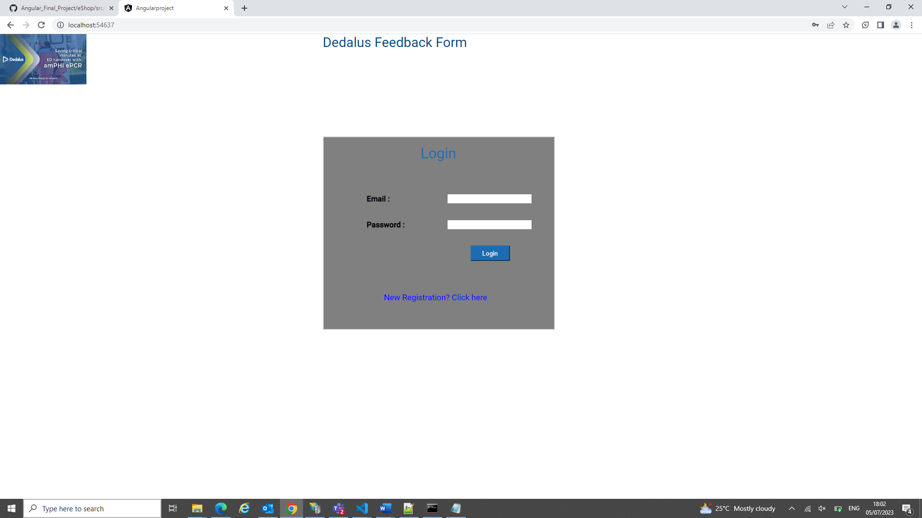

**Login validations:**

**Registration Page:**

**Registration validation:**

**Cancel Registration here will redirect to Login Page…**

**After login success based upon the user type by using lazy loading concept and routing concept page redirection is happened based on user type.**

**Admin landing page :**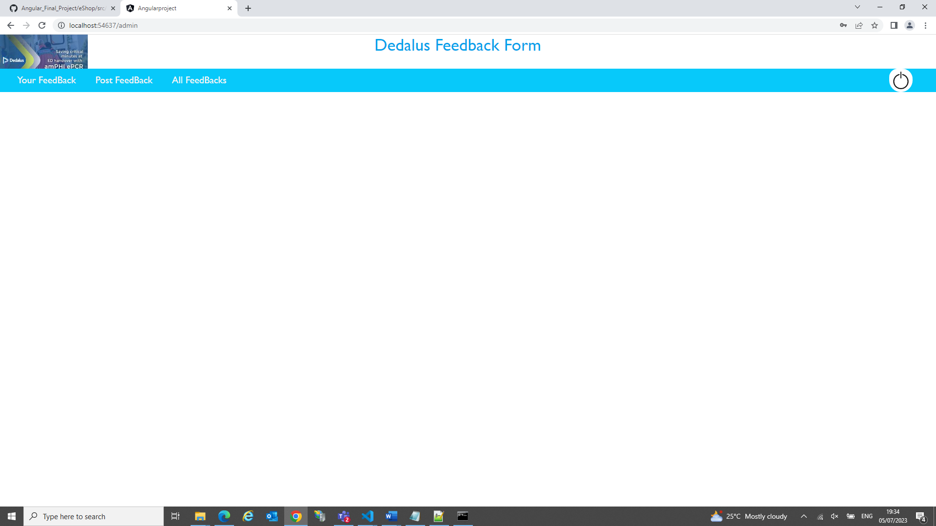

**Admin’s FeedBack Page:**

**Admin Submit Feedback Page:**

**Admin Feedback submitted successfully:**

**All Users Feedback Except Admin’s Page:**

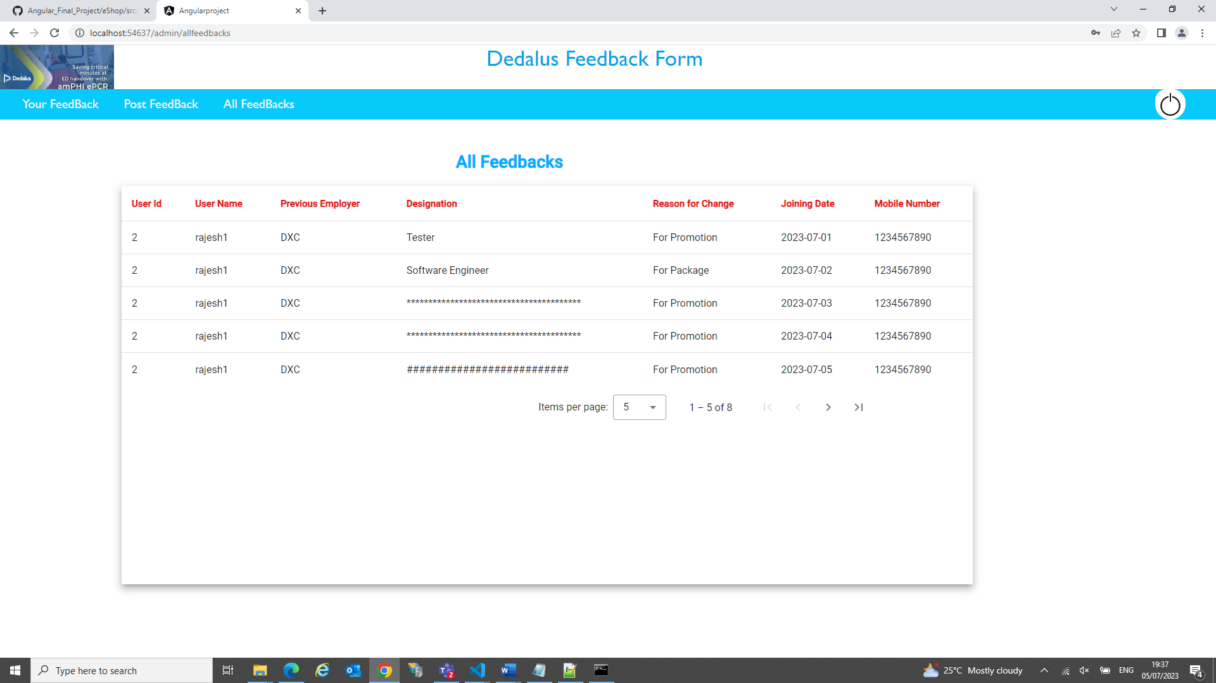

**LogOut Page:**

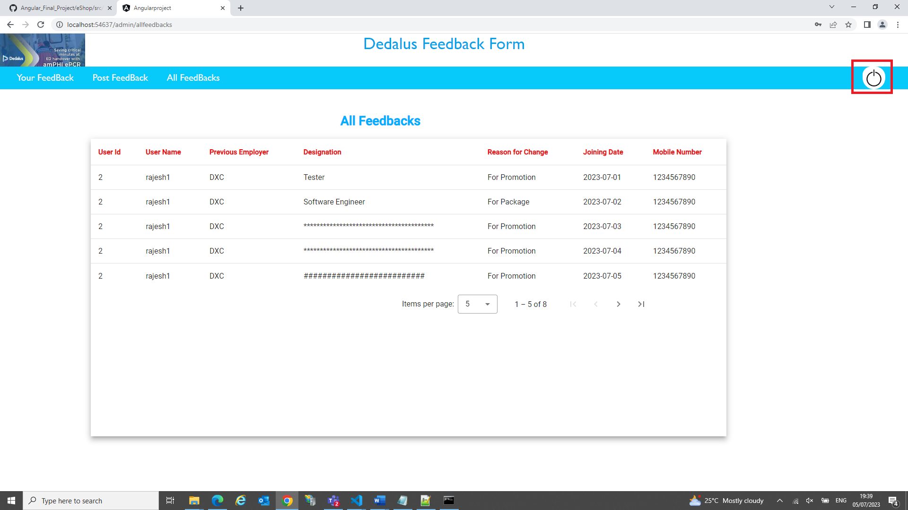

**Users Feedback Page:**

**User Feedback Submission Page:**

